It is a great pleasure to be selected among 4,000 applicants participate in the next 48-hours of the [**#MITCOVID19Challenge**](https://www.linkedin.com/feed/hashtag/?keywords=mitcovid19challenge&highlightedUpdateUrns=urn%3Ali%3Aactivity%3A6679900237613539328). Looking forward to an exciting and meaningful weekend.  
  
I am on Track F - Supporting maginalized communiting in confronting the epidemic.

[**#covid19**](https://www.linkedin.com/feed/hashtag/?keywords=covid19&highlightedUpdateUrns=urn%3Ali%3Aactivity%3A6679601048685944832) [**#MIT**](https://www.linkedin.com/feed/hashtag/?keywords=mit&highlightedUpdateUrns=urn%3Ali%3Aactivity%3A6679601048685944832) [**#COVID19**](https://www.linkedin.com/feed/hashtag/?keywords=covid19&highlightedUpdateUrns=urn%3Ali%3Aactivity%3A6679601048685944832) [**#flattenthecurve**](https://www.linkedin.com/feed/hashtag/?keywords=flattenthecurve&highlightedUpdateUrns=urn%3Ali%3Aactivity%3A6679601048685944832) [**#coronavirus**](https://www.linkedin.com/feed/hashtag/?keywords=coronavirus&highlightedUpdateUrns=urn%3Ali%3Aactivity%3A6679601048685944832) [**#hacking**](https://www.linkedin.com/feed/hashtag/?keywords=hacking&highlightedUpdateUrns=urn%3Ali%3Aactivity%3A6679601048685944832) [**#pandemic**](https://www.linkedin.com/feed/hashtag/?keywords=pandemic&highlightedUpdateUrns=urn%3Ali%3Aactivity%3A6679601048685944832) [**#crisis**](https://www.linkedin.com/feed/hashtag/?keywords=crisis&highlightedUpdateUrns=urn%3Ali%3Aactivity%3A6679601048685944832) [**#isolation**](https://www.linkedin.com/feed/hashtag/?keywords=isolation&highlightedUpdateUrns=urn%3Ali%3Aactivity%3A6679601048685944832) [**#solutions**](https://www.linkedin.com/feed/hashtag/?keywords=solutions&highlightedUpdateUrns=urn%3Ali%3Aactivity%3A6679601048685944832) [**#hackathon**](https://www.linkedin.com/feed/hashtag/?keywords=hackathon&highlightedUpdateUrns=urn%3Ali%3Aactivity%3A6679601048685944832) [**#latam**](https://www.linkedin.com/feed/hashtag/?keywords=latam&highlightedUpdateUrns=urn%3Ali%3Aactivity%3A6679601048685944832)

Social aspirations vs economic realities.

Starvation, domestic violence

In Switzerland, no brainer to do lockdown since only 4 people poor. 70% in Peru. 30% don’t have a fridge.

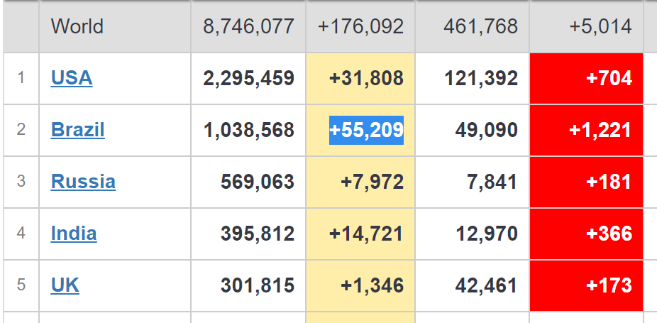

Hi everyone, I am Tanya Gupta, a final year mechanical engineering student in India with interests in robotics and human-centered design. Why this idea resonated with me was because it actually tackled the problem statement for Track A and there is huge scope for expansion and implementation in the real word, and it is also the need of the hour, specially seeing it seems China has had a coronavirus breakout in Beijing precisely because of the lack of follow up, and in South Korea people who were already infected by Coronavirus were affected again. The only reservation I have is since I am Indian I am not aware what is the scenario for internet and technology access in LatAm, and if an app would even be a viable tool for doing the tracking. But otherwise, great idea, great pitch, and really looking forward to working on it!